GROUP 3 MEMBERS-MASAKA

WALAKIRA DERRICK 2018-B072-30022

MATOVU BENEDICT 2018-B072-30009

NABUKENYA JANE FRANCES 2018-B072-30021

NAKIBUUKA RACHEAL 2018-B072-30026

KYANDA ALEX 2018-B072-30007

**SYSTEM DESIGN**

*Question: Come up with design models and Specifications for your software project. Use a software of your choice for modelling. NB: You are revise chapter 5 and read chapter 6 and 7 of the reference books before doing the project*

**Structure of the proposed system**

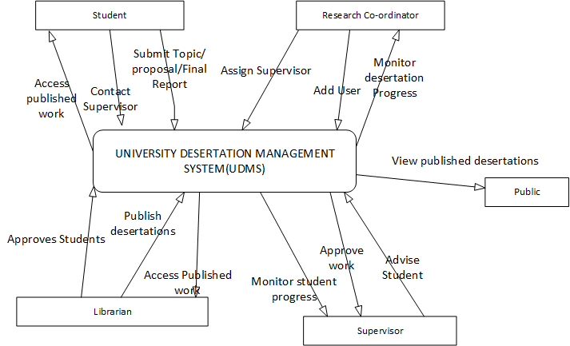

Figure 1: The diagram highlights the system functionalities and associated stakeholders.

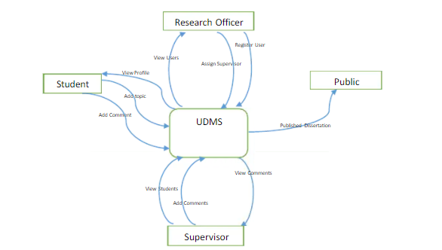

Figure Context Data Flow Diagram for UDMS

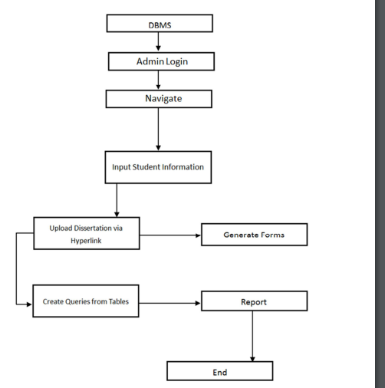

Figure : System Architecture Design.





